VJ COLLAB

A Summer Internship Project Report Submitted in partial fulfillment of the requirements for the award of the degree of

**BACHELOR OF TECHNOLOGY IN**

**CSE (ARTIFICIAL INTELLIGENCE & MACHINE LEARNING)**

Submitted by

Mr. G. Sai Teja (20071A6614)

Mr. M. Sai Ritish Reddy (20071A6626)

Mr. M. Uday Krishna (20071A6627)

Mr. M. Harikesh (20071A6629)

Under the guidance of

**Dr. A. Harshavardhan**

**(Sr. Assistant Professor, Department of CSE-AIML & IoT, VNR VJIET)**



**DEPARTMENT OF CSE (ARTIFICIAL INTELLIGENCE & MACHINE LEARNING)**

**VALLURUPALLI NAGESWARA RAO VIGNANA JYOTHI INSTITUTE OF ENGINEERING AND TECHNOLOGY**

An Autonomous Institute, NAAC Accredited with ‘A++’ Grade NBA Accredited for CE, EEE, ME, ECE, CSE, EIE, IT B. Tech Courses Approved by AICTE, New Delhi,

Affiliated to JNTUH Recognized as “College with Potential for Excellence” by UGC ISO 9001:2015 Certified, QS I GUAGE Diamond Rated

Vignana Jyothi Nagar, Pragathi Nagar, Nizampet (S.O), Hyderabad – 500 090, TS, India

**VALLURUPALLI NAGESWARA RAO VIGNANA JYOTHI INSTITUTE OF ENGINEERING AND TECHNOLOGY**

An Autonomous Institute, NAAC Accredited with ‘A++’ Grade NBA Accredited for CE, EEE, ME, ECE, CSE, EIE, IT B. Tech Courses Approved by AICTE, New Delhi,

Affiliated to JNTUH Recognized as “College with Potential for Excellence” by UGC ISO 9001:2015 Certified, QS I GUAGE Diamond Rated

Vignana Jyothi Nagar, Pragathi Nagar, Nizampet (S.O), Hyderabad – 500 090, TS, India

**DEPARTMENT OF CSE (ARTIFICIAL INTELLIGENCE & MACHINE LEARNING)**



**CERTIFICATE**

This is to certify that the project report entitled “**VJ COLLAB”** is a bonafide work done under our supervision and is being submitted by **Mr. G. Sai Teja (20071A6614), Mr. M. Sai Ritish Reddy (20071A6626), Mr. M. Uday Krishna (20071A6627), Mr. M. Harikesh (20071A6629)** in partial fulfillment for the award of the degree of Bachelor of Technology in CSE(Artificial Intelligence and Machine Learning), of the VNRVJIET, Hyderabad during the academic year 2022-2023. Certified further that to the best of our knowledge the work presented in this thesis has not been submitted to any other University or Institute for the award of any Degree or Diploma.

**Dr. A. Harshavardhan**

**Sr. Assistant Professor**

**Dept. of CSE (AIML & IoT)**

**VNRVJIET**

**Dr. N. Sandhya**

**Professor& HOD**

**Dept. of CSE (AIML & IoT )**

**VNR VJIET**

**VALLURUPALLI NAGESWARA RAO VIGNANA JYOTHI INSTITUTE OF ENGINEERING AND TECHNOLOGY**

An Autonomous Institute, NAAC Accredited with ‘A++’ Grade NBA Accredited for CE, EEE, ME, ECE, CSE, EIE, IT B. Tech Courses Approved by AICTE, New Delhi,

Affiliated to JNTUH Recognized as “College with Potential for Excellence” by UGC ISO 9001:2015 Certified, QS I GUAGE Diamond Rated

Vignana Jyothi Nagar, Pragathi Nagar, Nizampet (S.O), Hyderabad – 500 090, TS, India

**DEPARTMENT OF CSE (ARTIFICIAL INTELLIGENCE & MACHINE LEARNING)**



**DECLARATION**

We declare that the major project work entitled “**VJ COLLAB**” submitted in the department of CSE(Artificial Intelligence and Machine Learning), Vallurupalli Nageswara Rao Vignana Jyothi Institute of Engineering and Technology, Hyderabad, in partial fulfillment of the requirement for the award of the degree of **Bachelor of Technology** in **CSE(Artificial Intelligence and Machine Learning)** is a bonafide record of our own work carried out under the supervision of **Dr. A. Harshvardhan, Sr.Assistant Professor, Department of CSE(AIML & IoT), VNRVJIET**. Also, we declare that the matter embodied in this thesis has not been submitted by us in full or in any part thereof for the award of any degree/diploma of any other institution or university previously.

Place: Hyderabad

|  |  |  |  |
| --- | --- | --- | --- |
| **G. Sai Teja** | **M. Sai Ritish Reddy** | **M. Uday Krishna** | **M. Harikesh** |
| (20071A6629) | (20071A6626) | (20071A6627) | (20071A6629) |

**ACKNOWLEDGEMENT**

Firstly, we would like to express our immense gratitude towards our institution VNR Vignana Jyothi Institute of Engineering and Technology, which created a great platform to attain profound technical skills in the field of Computer Science, thereby fulfilling our most cherished goal.

We are very much thankful to our Principal, **Dr. Challa Dhanunjaya Naidu,** and our Head of Department, **Dr. N. Sandhya**, for extending their cooperation in doing this project within the stipulated time.

We extend our heartfelt thanks to our guide, **Dr. A. Harshavardhan,** and the project coordinators **Dr. A. Harshavardhan**, and **Mrs. P. Nethrasri** for their enthusiastic guidance throughout the course of our project.

Last but not least, our appreciable obligation also goes to all the staff members of the Computer Science & Engineering department and to our fellow classmates who directly or indirectly helped us.

**Mr. G. Sai Teja (20071A6614)**

**Mr. M. Sai Ritish Reddy (20071A6626)**

**Mr. M. Uday Krishna (20071A6627)**

**Mr. M. Harikesh (20071A6629)**

**ABSTRACT**

Collaboration and discussions among the students are very important during their academic study routine. New ideas, doubts, and discussions help students to learn new concepts. Our team has observed a lack of collaborative nature among peers at the institute level. Our idea is to create a platform where students from various branches and years can come and collaborate with other students in the institute.

The platform would help students collaborate with cross-domain students, provides a place for discussions on new technologies, and also as a forum website for instant query answers. Our idea is to create a web application where students from the institute can post discussion queries, and collaboration requests to the application where any other students can comment and respond to the requested queries. The application contains features of an anonymous user, groups for topic-wise discussions, instant queries, comments, and on a query, closing requested queries. The portal will also contain advanced features like content verification.

**TABLE OF CONTENTS**

i. Title Page i

ii. Certificate ii

iii. Declaration iii

iv. Acknowledgment iv

v. Abstract v

vi. Table of Contents vi

1. INTRODUCTION

1.1 Existing System

1.2 Proposed System

2. LITERATURE SURVEY

2.1 Related Survey

2.2 System Study

3. DESIGN

3.1 Requirements Specifications (S/W & H/W)

3.2 UML Diagrams / DFDs

4. IMPLEMENTATION  
 4.1 Working Methodology

4.2 Algorithms

5. TESTING

5.1 Test Cases

5.2 Test Results

6. Results

7. Conclusions and Further Scope

8. Bibliography

**CHAPTER 1**

**INTRODUCTION**

* 1. **EXISTING SYSTEM:**
* Presently collaborative and networking websites such as quora and LinkedIn serve as a platform for networking among students.
* These websites cater to a greater audience around the world and help people connect globally.
* Though these websites are great and work accordingly, users find it hard to collaborate among organizations and universities.
* Long waiting times to connect and message fellow students in the universities are time-consuming and not efficient when the need is urgent.
* When the need is urgent the above networking sites cannot perform well as it is hard to connect through and no guarantee you would get a reply from that specific person.
* These problems are especially faced by the students when they work on cross-domain projects or team formation for hackathons, etc**…**

**1.2 PROPOSED SYSTEM**

* We are working on a web application in which students from our college can post content regarding collaboration requests and discussion queries related to their projects.
* The students of our college only have permission to join this is done through email authentication.
* This helps the students to complete their projects, by taking help from other students of various branches and different ideas together.
* The student at the other end can review the strength of other students and make as a collaborator in the project.
* People in a group with different ways of thinking can lead to something better than being struck off with older ideas.
* The discussion forum helps to discuss the doubts instead of browsing because without effective browsing one may not get the solution so, students who already solved the same question or have an idea of the solution can help with the question.
* This helps the student to get the solution to their current working error or project
* The students get the project recommendation based on their branches and time-based priority.

**CHAPTER 2**

**LITERATURE SURVEY**

**2.1 RELATED WORK:**

* Increases productivity: Project collaboration tools allow project managers to evenly distribute tasks to team members, rather than burdening one team member with too much work. Proper task management gives teams more time, which facilitates team collaboration.
* Better problem-solving: Giving team members the project collaboration tools to share files and communicate in real-time allows them to work together to solve problems.
* Boosts Team Communication: The lines of communication that need constant maintenance or misdirection can sidetrack a project. Project collaboration tools facilitate clear communication among your project team members and provide a solution to communicate effectively among even remote teams.
* Great for Remote Teams: One of the bigger costs in any organization is renting or buying a physical office in which everyone can work. With online project collaboration tools, however, remote teams can collaborate in real-time.
* Facilitates Team Building: By fostering team collaboration you’re not only building relationships but creating loyalty that helps build a collaborative project management environment.
* The students may also know about various problems and get to know about them.
* In collaboration, one can collaborate with various students or different branch students this help every student to get know new knowledge.

**2.2 SYSTEM STUDY**

* + Team Building Activities:

There are team-building activities that accelerate bonding between team members. These can be as simple as taking everyone out to lunch to engaging in more structured games, such as charades, sports, and so forth. Whatever you choose to do it should be before the project to start building more collaborative teams.

* + Focus on the Discussion portal:

Communication is the glue that holds together any collaborative environment. Whether that’s regular meetings, setting up a real-time chat tool, or even a message board, there must be a way to disseminate information to everyone quickly and also capture feedback from team members.

* + Selects the Team with the Right Task Management Tools:

Managing tasks is how to get teams working not only collaboratively but more productively. If all these project views are updated with the same real-time data then it allows everyone to work better together with the tools they’re most comfortable with.

* + Manages the Team Members’ Workflow using Discussion Portal:

Workflow is essential to productivity and works hand-in-glove with task management tools. This lets team members work how they want, managing their workflow.

**CHAPTER 3**

**DESIGN**

**3.1 REQUIREMENT SPECIFICATIONS**

**3.1.1 Hardware Used**

Client Side:

Processor: 166 MHz or above

RAM: 8 MB

Hard Disk Space: 100 MB

Server Side:

Processor: 2.0 GHz or above

RAM: 64 GB

Hard Disk Space: 300 MB

**3.1.2 Software Used**

Operating System: Windows/Mac-OS

Language: JavaScript

Frameworks: ReactJS, React Bootstrap, Firebase

Tools: vscode

**3.2 UML DESIGNS**

**3.2.1 Use Case:**

* A use case diagram is a graphical depiction of a user’s possible interactions with a system.
* A use case diagram shows various use cases and different types of users of the system.
* The use cases are represented by either circles or ellipses. The actors are often shown as stick figures.

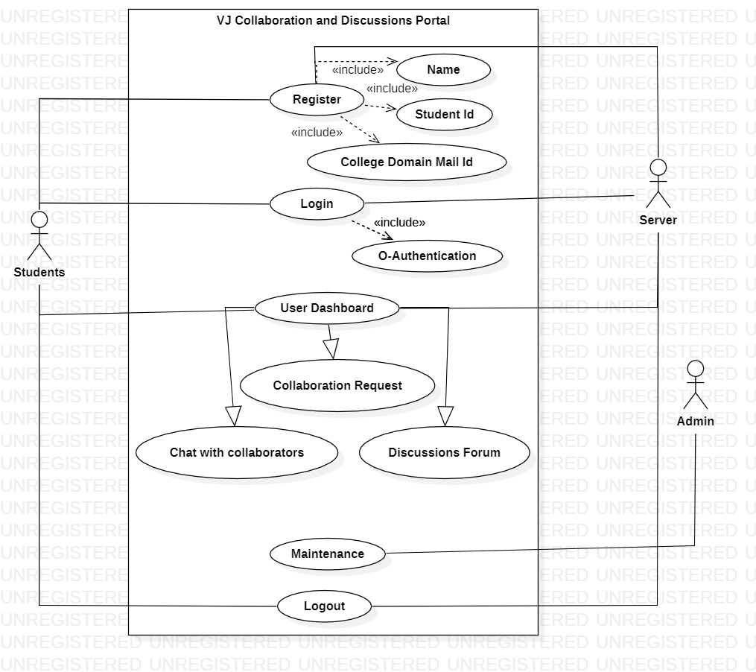

Fig 3.1 – Use Case Diagram of VJ Collab

**3.2.2 Class Diagram**

* The class diagram depicts a static view of an application. It represents the types of objects residing in the system and the relationships between them.
* A class consists of its objects, and it may inherit from other classes. A class diagram is used to visualize, describe, and document various aspects of the system.
* It shows the attributes, classes, functions, and relationships to give an overview of the software system.
* It constitutes class names, attributes, and functions in a separate compartment that helps in software development.

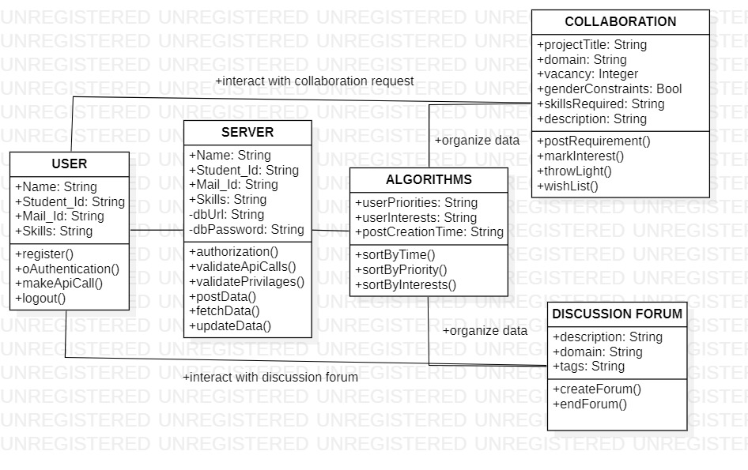

Fig 3.2 – Class Diagram for VJ Collab

**3.2.3 Sequence Diagram**

* A sequence diagram is a type of interaction diagram because it describes how and in what order a group of objects works together.
* These diagrams are used by software developers and business professionals to understand requirements for a new system or to document an existing process
* Sequence diagrams are sometimes known as event diagrams or event scenarios.
* Sequence diagrams can be useful references for businesses and other organizations.

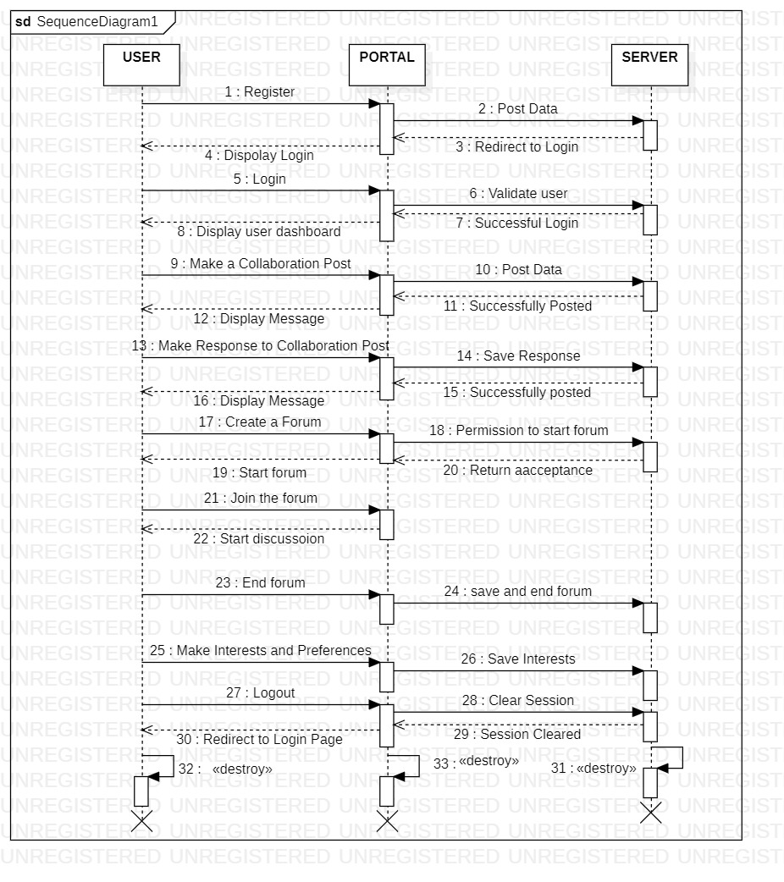

Fig 3.3 – Sequence Diagram of VJ Collab

**CHAPTER 4**

**IMPLEMENTATION**

**4.1 WORKING METHODOLOGY**

* The students of VNR VJIET can log in to VJ Collab by using their respective college email id (abc@vnrvjiet.in).
* Students can either go into the collaboration portal or forum portal on the home screen. The collaboration page consists of all the requests made by fellow students from VNR VJIET request for collaboration/finding a team for a project or hackathon. The forum page consists of all the questions one can face during building a project or can be any college-related queries too.
* On the collaboration page, the cards contain information such as the title of the project/hackathon, description of the project, last date to apply, number of collaborators needed for the project, and the skill set one must be having for the project.
* Upon applying for a particular project, a drop-down box appears where you can select the rating of the skills (out of 5) specified in the project. A request will be sent to the admin of the post and will appear on their dashboard.
* The admin/owner of the post can see the collaborator name, LinkedIn profile, and selected rating. He/she has the option of accepting or rejecting in the dashboard upon which the changes will be reflected in both the user's dashboard.
* On the forum page, one can ask a question by clicking the button new question. The question must contain the title of the query, a description of the query, domain of the query like technical/non-technical.
* The users can reply to the question from the answer box given below. The answers are sorted according to the time and a text display when the post was created.

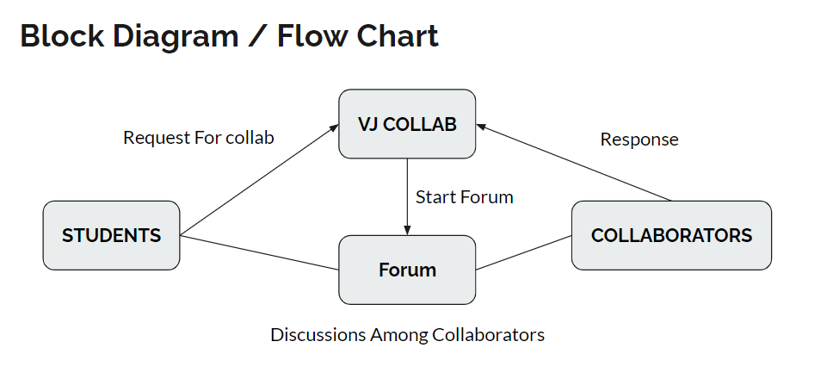

Fig 4.1 Flow chart of VJ Collab

**4.2 ALGORITHMS**

As VJ collab is a web application it involves real-time CRUD operations. Performing these operations in real-time needs optimized NoSQL queries from the cloud firestore database. The algorithms we have used in this application are:

* Real-time updating, and deletion of data from the database by using the snapshot query from firebase reducing time to refresh the page every time.
* Users sign in from their google account, specifically emails ending with @vnrvjiet.in using regex expressions.
* Posts are sorted according to date/time i.e., posted 1 hour ago, etc...
* Date/time calculation using moment.js
* Sort and Filter options based on the domain of the project.

**CHAPTER 5**

**5.1 TEST CASES**

1. Login with Email Id

2. Sorting user feed

3. Filtering user feed.

4. Realtime user feed update.

**5.2 TEST RESULTS**

**5.2.1 Login with Email Id**

|  |  |  |  |  |  |  |  |  |  |
| --- | --- | --- | --- | --- | --- | --- | --- | --- | --- |
| ID | Test Scenario Description | Test Case Id | Test Case Description | Test Steps | Test Data | Pre-Conditions | Output Test-Case Execution Result | Actual Result | Status |
| VNR COLLAB 001 | Verify the login | VNR COLLAB login 001 | Valid email-authentication | 1.Click on login  2.Select the mail provided by the college  3.Provided with correct college mail id | abc@vnrvjiet.in | The email should end with vnrvjiet.in | Home Page | Home page | Success |
| VNR COLLAB 002 | Verify the login | VNR COLLAB login 002 | Valid email-authentication | 1.Click on login  2.Select the mail provided by the college  3.Provided with in-correct college mail id | abc@gmail.com | The email should end with vnrvjiet.in | Home Page | A pop up the user had not a verified mail id | Failure |

**5.2.2 Sorting user feed**

|  |  |  |  |  |  |  |  |  |  |
| --- | --- | --- | --- | --- | --- | --- | --- | --- | --- |
| ID | Test Scenario Description | Test Case ID | Test Case Description | Test Steps | Test Data | Pre-Conditions | Output  Test Case Execution Result | Actual Result | Status |
| VNR COLLAB 011 | Sorting the feed | VNR COLLAB sorting 011 | Sorting the user feed using the time stamp | 1.Check the time stamp | 1.User server time stamp same as posted user server time stamp | This should be our local time stamp | Sorted Feed | Sorted Feed | Success |
| VNR COLLAB 012 | Sorting the feed | VNR COLLAB sorting 012 | Sorting the user feed using the time stamp | 1.Check the time stamp | 1.User server time stamp not same as posted user server time stamp | This should be our local time stamp | Wrong time stamp | Error | Failure |

**5.2.3 Filtering user feed**

|  |  |  |  |  |  |  |  |  |  |
| --- | --- | --- | --- | --- | --- | --- | --- | --- | --- |
| ID | Test Scenario Description | Test Case ID | Test Case Description | Test Steps | Test Data | Pre-Conditions | Output  Test Case Execution Result | Actual Result | Status |
| VNR COLLAB 013 | Filtering using the feed | VNR COLLAB sorting 013 | Filter the feed according to string provided | 1.check whether feed is present or not | AI | Checks the feed on AI | Feeds on AI | Feed on AI projects | Success |
| VNR COLLAB 014 | Filtering using the feed | VNR COLLAB sorting 014 | Filter the feed according to string provided | 1.check whether feed is present or not | AI | Checks the feed on AI | If it is empty displays nothing | Blank page | Failure |
| VNR COLLAB 015 | Filtering using the feed | VNR COLLAB sorting 015 | Filter the feed according to strings provided | 1.check whether feed is present or not | Web, AI | Checks for the feed on AI and Web | Feeds on AI and Web | Feeds on AI and Web | Success |
| VNR COLLAB 016 | Filtering using the feed | VNR COLLAB sorting 016 | Filter the feed according to strings provided | 1.check whether feed is present or not | Web  ,AI | Checks for the feed on AI and Web | Feeds of either AI or Web based on their present data | Feeds | Success |
| VNR COLLAB 017 | Filtering using the feed | VNR COLLAB sorting 017 | Filter the feed according to strings provided | 1.check whether feed is present or not | Web  ,AI | Checks for the feed on AI and Web | No data based on strings | Blank Page | Failure |

**5.2.4 Filtering user feed**

|  |  |  |  |  |  |  |  |  |  |
| --- | --- | --- | --- | --- | --- | --- | --- | --- | --- |
| ID | Test Scenario Description | Test Case ID | Test Case Description | Test Steps | Test Data | Pre-Conditions | Output  Test Case Execution Result | Actual Result | Status |
| VNR COLLAB 018 | Real time feed update | VNR COLLAB update 018 | Updating the feed on creating the feed by the user | 1.Click post button to add the post | Internet Connectivity | Stable internet | Feed is updated | A pop up which show the feed is added. | Success |
| VNR COLLAB 019 | Real time feed update | VNR COLLAB update 019 | Updating the feed on creating the feed by the user | 1.Click post button to add the post | Internet Connectivity | No stable internet | Feed is not Updated | A pop up which show the error message. | Failure |

**CHAPTER 6**

**RESULTS**

**6.1 FRONTEND**

**6.1.1 Home Screen:**

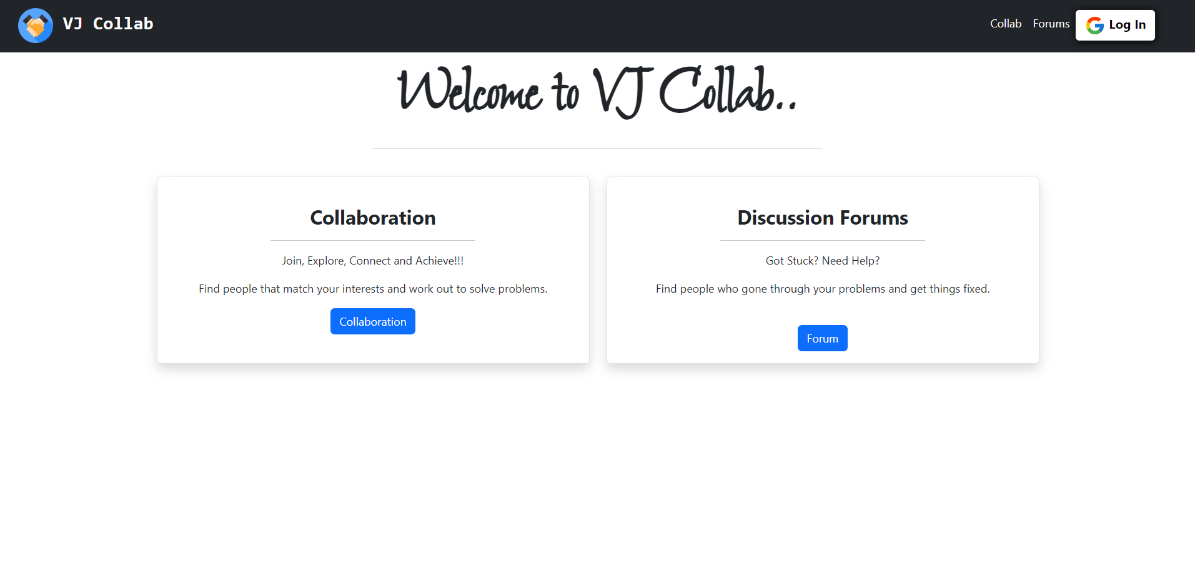

Fig 6.1.1 – Home Screen of VJ Collab

The Home screen of VJ Collab web application consists of two sections Collaboration and Forums.

On clicking the Collaboration button it renders the /collab URL that generates the collaboration page. This page has all the collaboration posts posted by various users.

On clicking the Forums button it renders the /forum URL that generates the discussion forums page. This page has all the questions posted by users.

**6.1.2 Collaboration Page:**

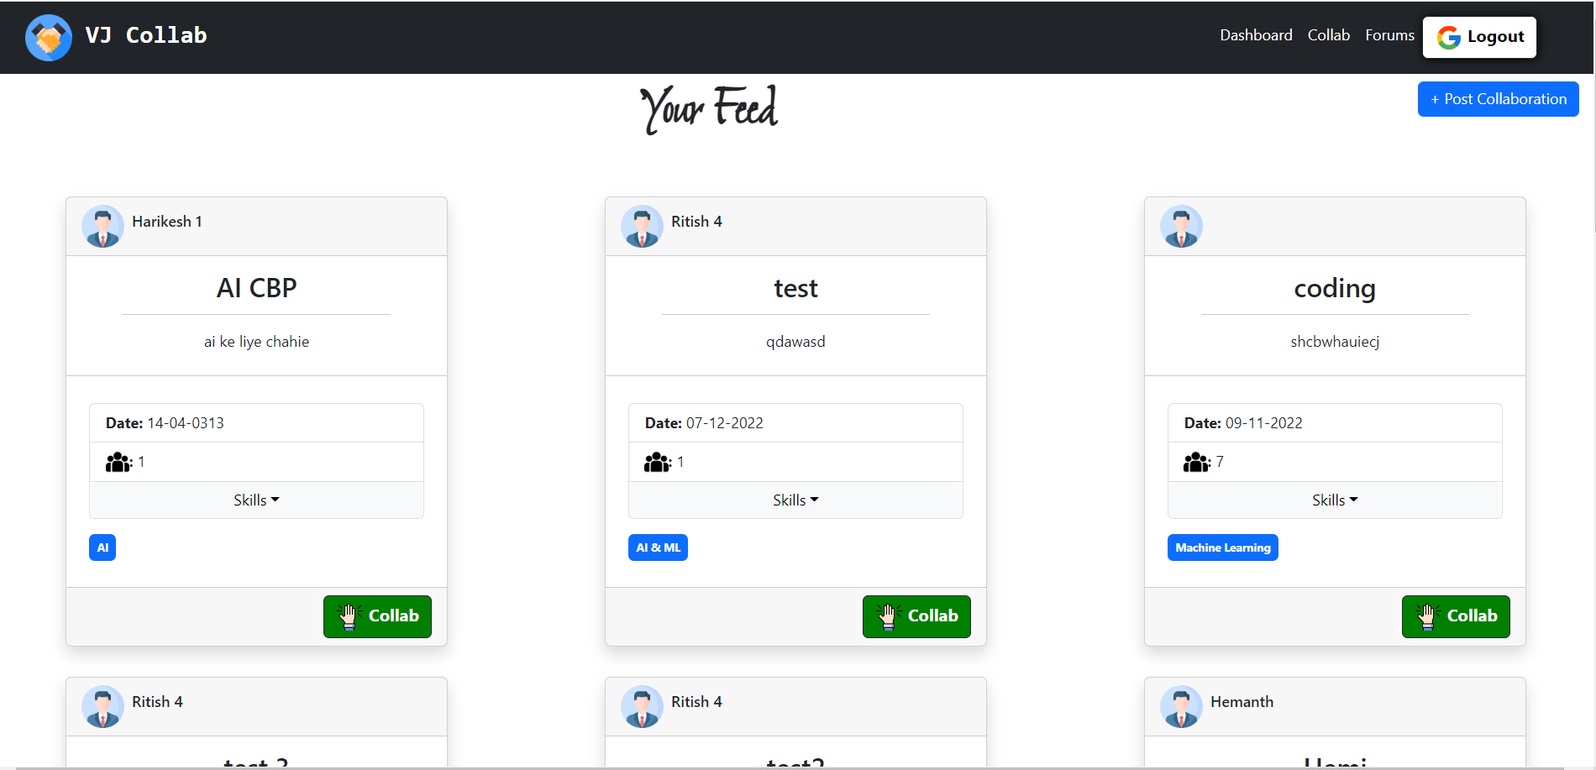

Fig 6.1.2 – Collaboration Page of VJ Collab

The Collaboration page at the URL ‘…/collab’ renders the Collaborations page. This page has 2 sections:

* 1. View Collaboration Requests.
  2. Post a collaboration Request.

**1. View Collaboration Requests:**

User can view other user’s collaborations request and find the details of the collabartion event through description.

He can also see the domain and skills required (as dropdown) for this collaboration.

The interested uses who match the requirements can click the Collab button to show interest.

**2. Post Collaboration Requests:**

The user can also post his own collaboration request with the button available at the top right corner. This helps the user find the people with similar interests and talent that he is looking for.

**6.1.3 Skill Set of VJ Hackathon Collaboration Post:**

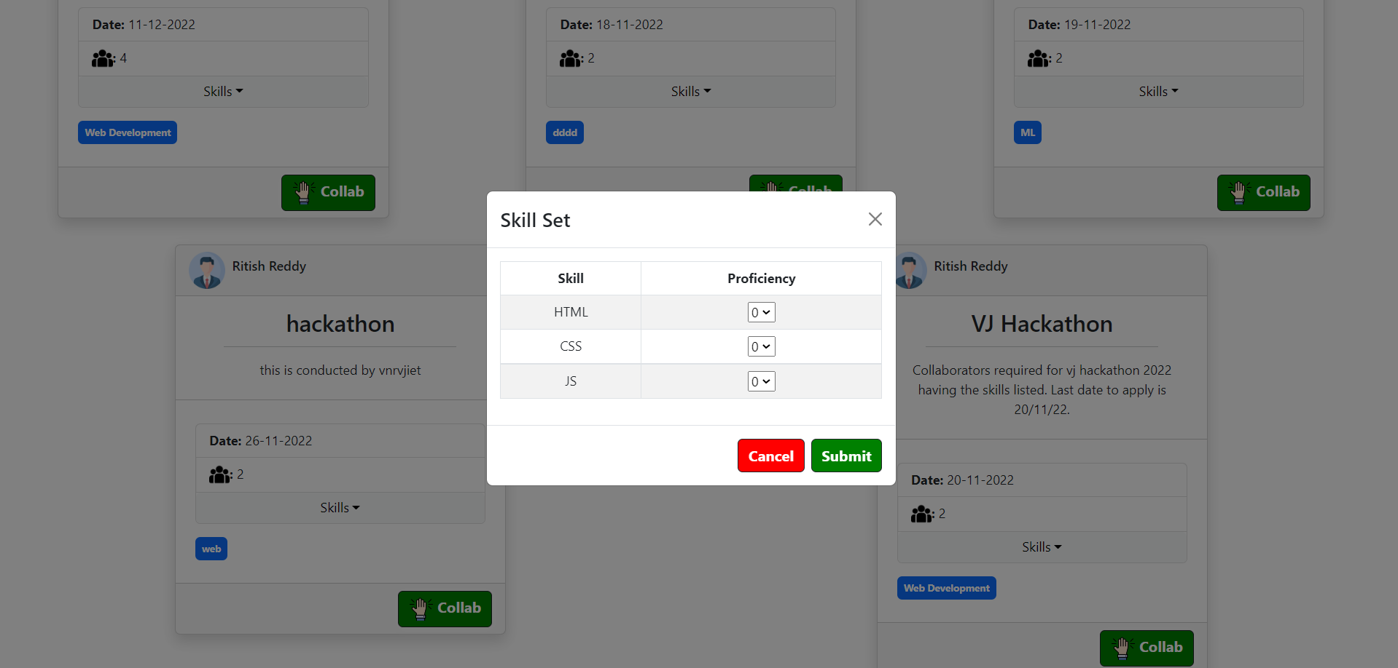

Fig 6.1.3 – Skill Set of VJ Hackathon post

The user who is interested in forming a collaboratin with another user can click on the collab button. Then he finds a skill set modal that the post owner is expecting. The user rates himself regarding the proficiency in those skills.

Thus on click of submit collaboration request will be sent.

**6.1.4 Post Collaboration Request:**

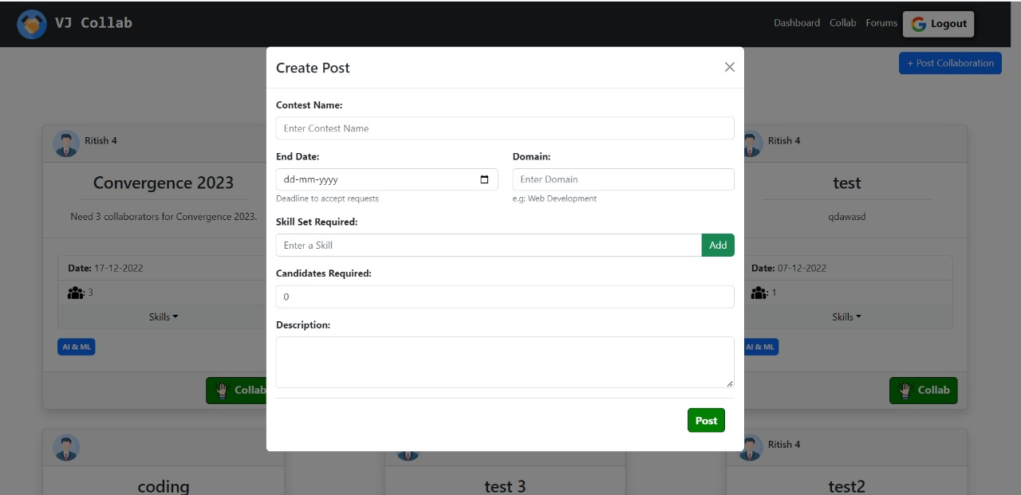  
Fig 6.1.4 – collaboration request post form

This is the collaboration request post form. This is used to post a collaboration request. This form takes the event details like event name, description, event domain, end date of accepting collaboration requests. The user can set the required skill set and number of persons required.

**6.1.5 User Dashboard:**

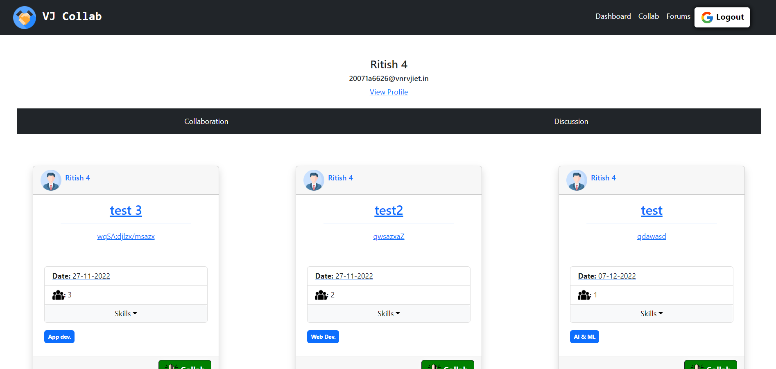

Fig 6.1.5 – Dashboard of User

The user dashboard is rendered at the URL ‘…/dashboard’. It is visisble on if the user is login to the portal. This consists of all the collaboration and discussions posted by the respective user.

This page has an internal routing for rendering user collaboration posts and discussion posts.

Through the view button (of collab post) in the respective post user can see the candidates who are interested in collaboration with him for the respective event.

Througth the view button (of discussions post) in the respective post user can see the answers given by various users for his question.

**6.1.6 View Collaboration Requests:**

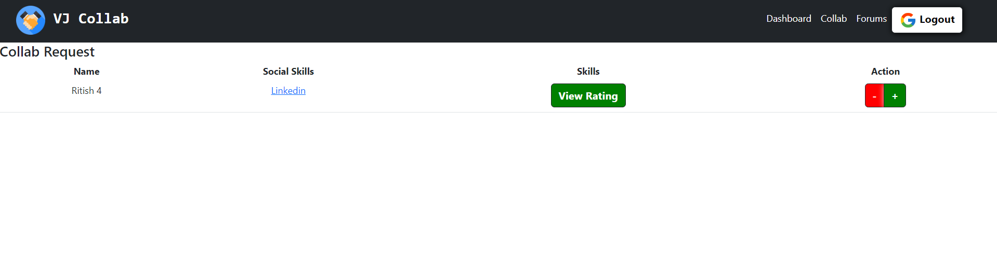

Fig 6.1.6– Collab Request in User Dashboard

By clicking on the view button on the collaboration post a new page will be rendered. This shows the users who showed interest to form a collaboration. The owner of the post can see the interested participants LinkedIn profile to analyze his skills. They can also see their proficiency in required skills and take decision accordingly.

**6.1.7 Discussions Forum Page:**

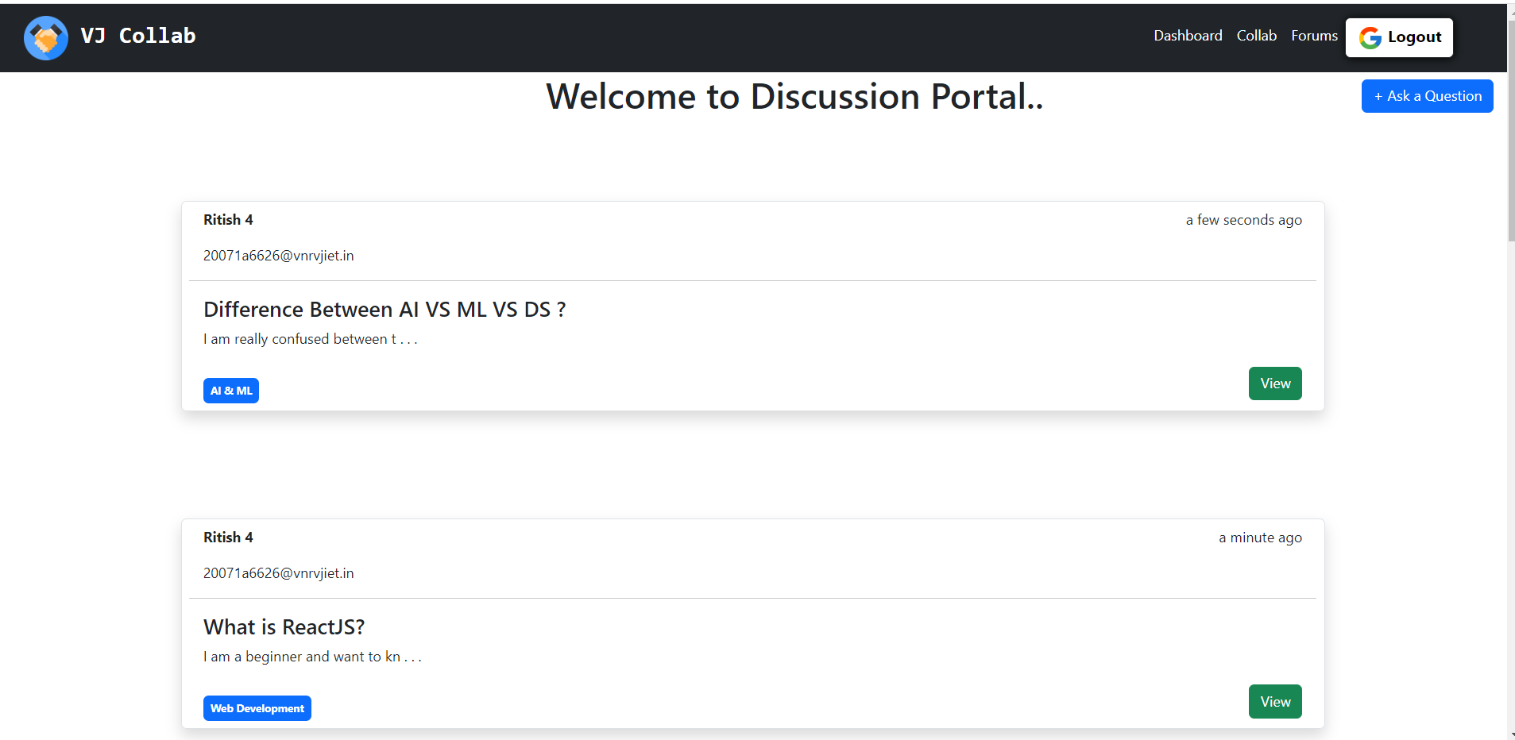

Fig 6.1.7– Forum Page of VJ Collab

This is the section where user can see the questions posted by other users. These questions are basically related to the technical glitches they faced in their projects. The user can see the question domain and title. If the question is familiar to the user, he can click on view to go through the question description and answer the question.

**6.1.8 Answering a Discussion Forum Question:**

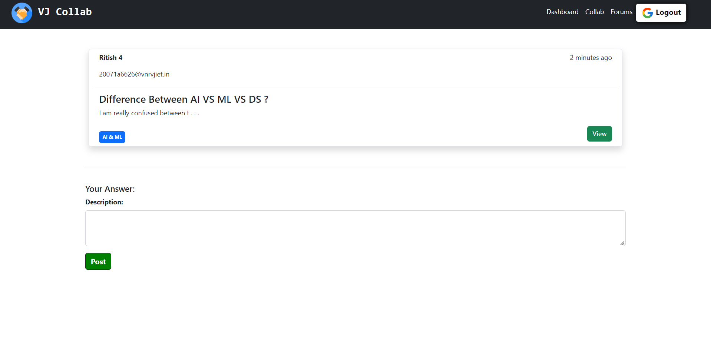

Fig 6.1.8 – Post answers in the forum portal

The user can view the question posted by other user in detail. He can also go through the answers given by other users. To add any suggestions or post a new answer he can also do it using the Your Answer feature at the bottom.

**6.1.9 Post a Question:**

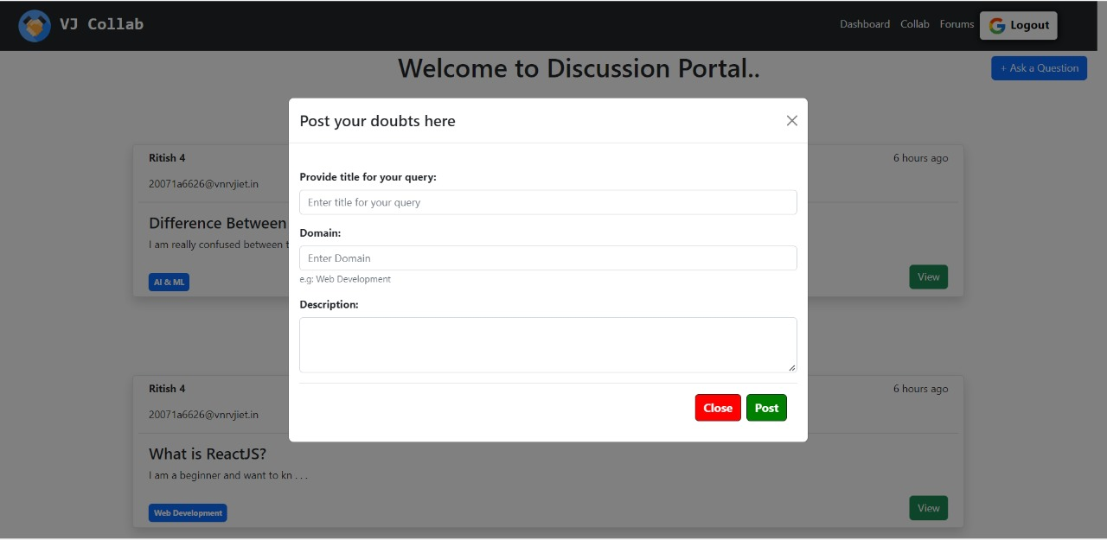

Fig 6.1.9 – Post a Discussion Forum Question

Onclicking the ‘ask a question’ button in discussion forum page we get a form to post our query / question. This form takes the title, domain and description to the question. On click of the post the question will be posted.

**6.1.10 View Answers to Forum Questions:**

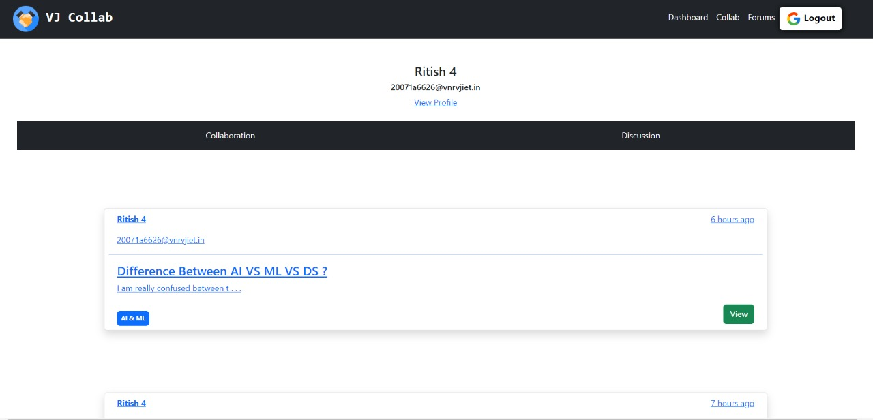

Fig 6.1.10 – View user posted questions

This section of the user dashboard shows the questions posted by him. On click of the view button the user will be shown all the answers / suggestions given by users to his question. He can also add anyother specific comment by making a answer in the same post section.

**6.1.11 Mobile Version of Web Application:**

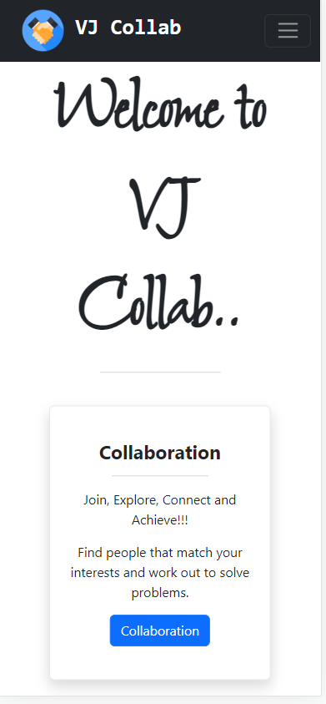 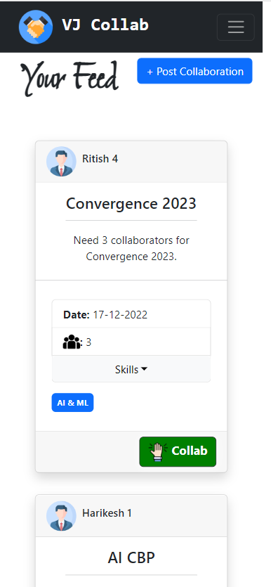 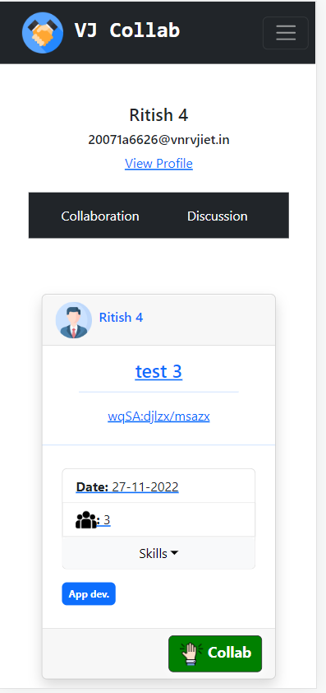

Fig 6.1.11 – Vj Collab in mobile.

This image shows the responsiveness of the web application in a mobile view.

**6.2 BACKEND**

**6.2.1 Cloud Firestore:**

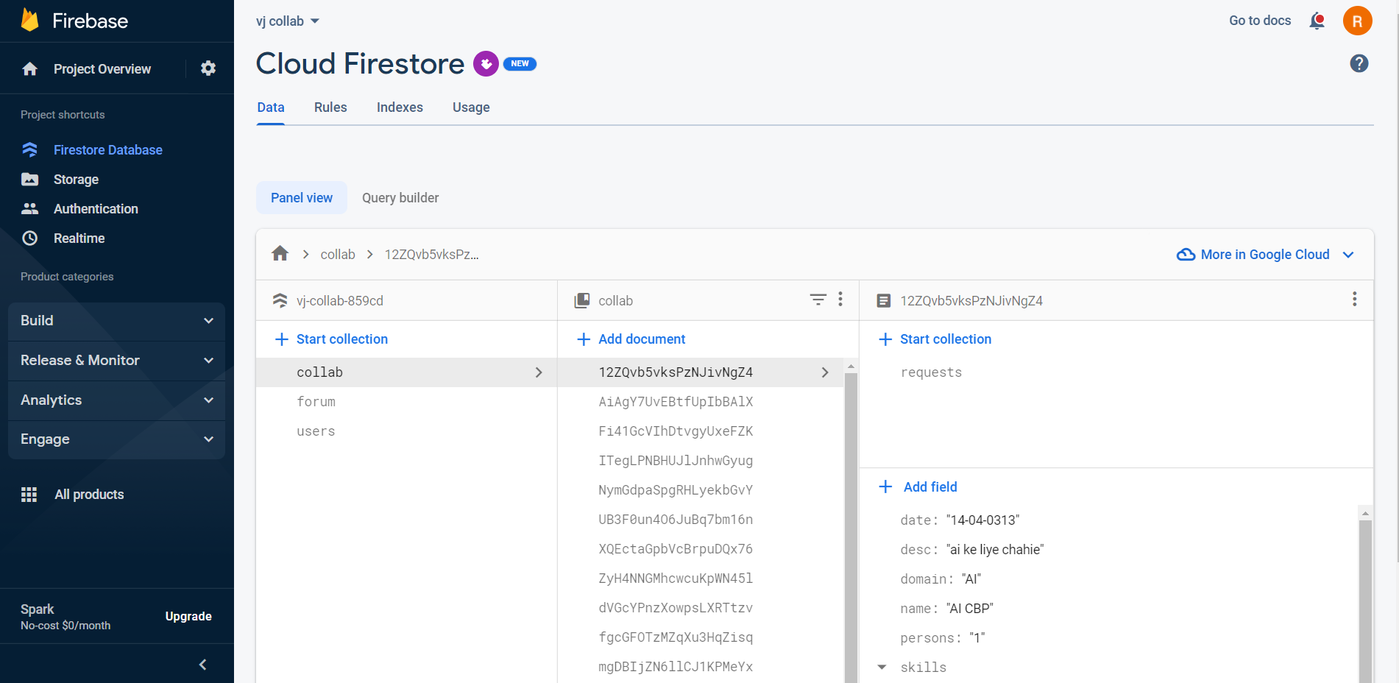

Fig 6.2.1 – Cloud Firestore (NoSQL Database)

The above image shows the console of the firestore database of firebase. The above mentioned database is a NoSQL cloud database. The above picture shows the different collections and documents (data records) used in the web application.

**6.2.2 Authentication Console:**

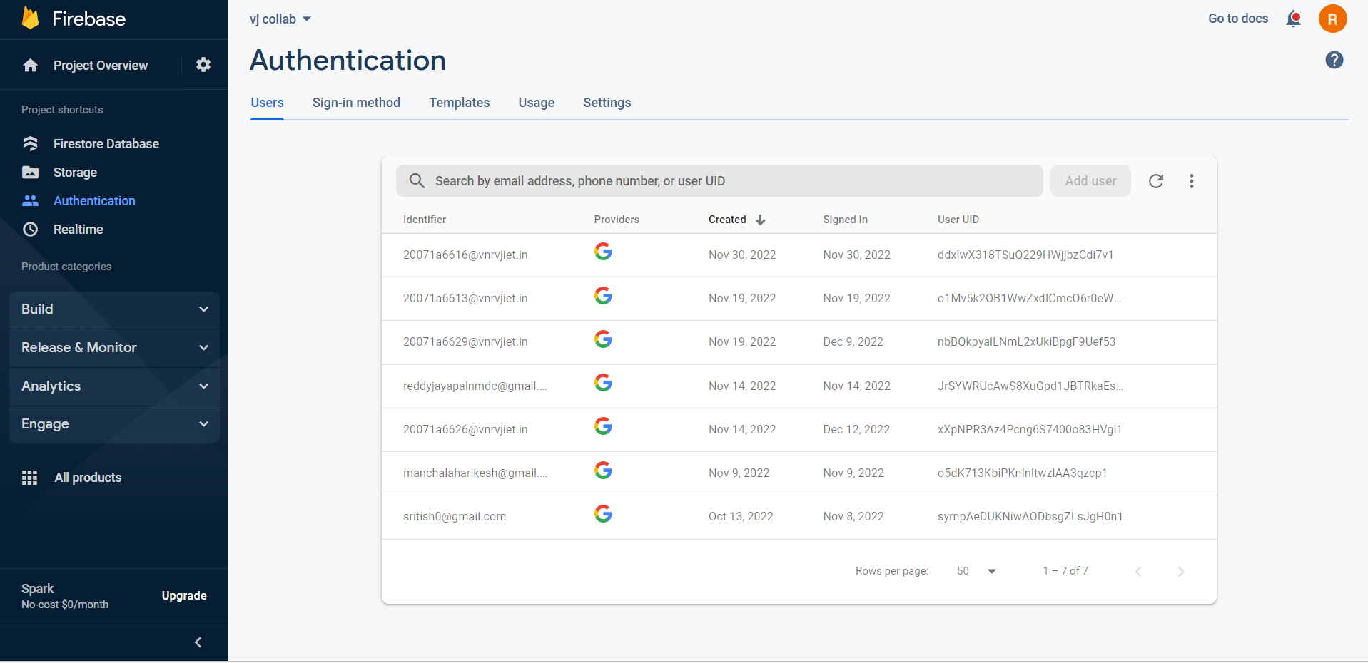

Fig 6.2.2 – Authentication

This is the authentication console of the firebase. This show stores the user details who loggedin to our portal using the Gmail OAuthentication.

**6.2.3 Collab Collection:**

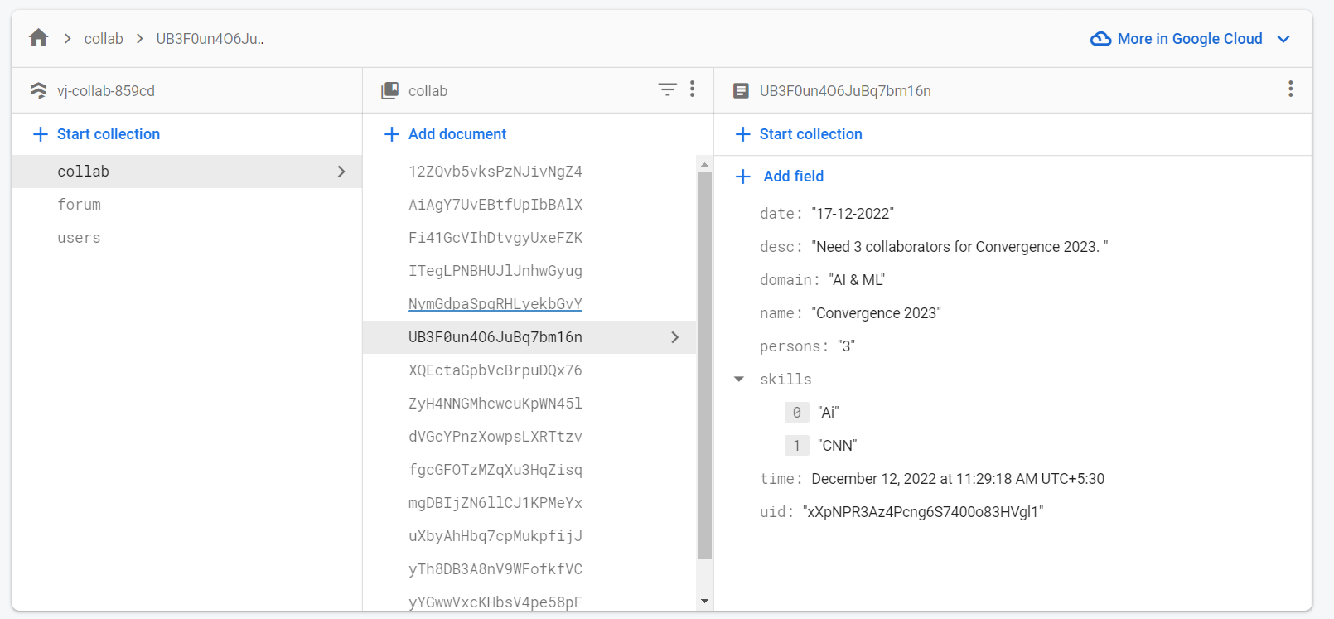

Fig 6.2.3 – Collab Collection

The above picture shows the collab collection. This consists of the collaboration post documents posted by users. The various data fields mentioned in the collaboration post form are shown above. This shows how the collaboration post data is stored and processed.

The above collection has many documents each of which has the unique document id generated by the firebase automatically. The collab document consits of different fields like:

1. End date

2. Description

3. Domain

4. Event name

5. Number of persons required

6. Timestamp to sort user feed

7. Uid of the person who posted the collab request.

**6.2.4 Forum Collection:**

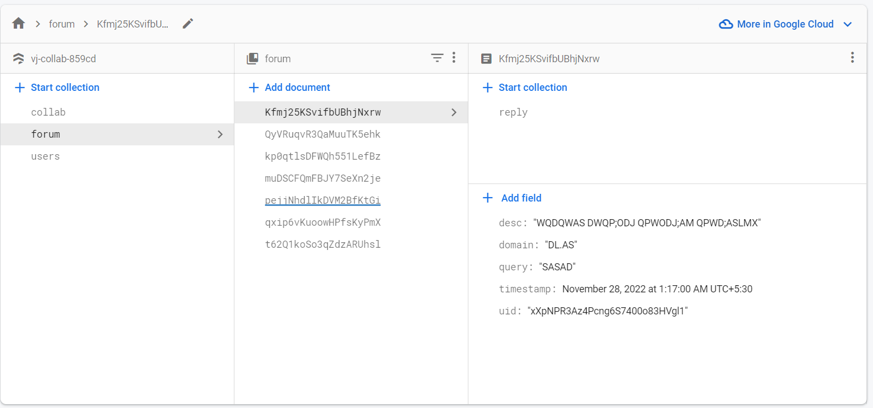

Fig 6.2.4 – Forum Collection

The above picture shows the forum collection. This consists of the discussion forum post documents posted by users. The various data fields mentioned in the disucssion forum post form are shown above. This shows how the discussion post data is stored and processed.

The above collection has many documents each of which has the unique document id generated by the firebase automatically. The collab document consits of different fields like:

1. Description

2. Domain

3. Title

4. Timestamp to sort user feed

5. Uid of the person who posted the collab request.

**6.2.5 Nested collection for Forum Replies:**

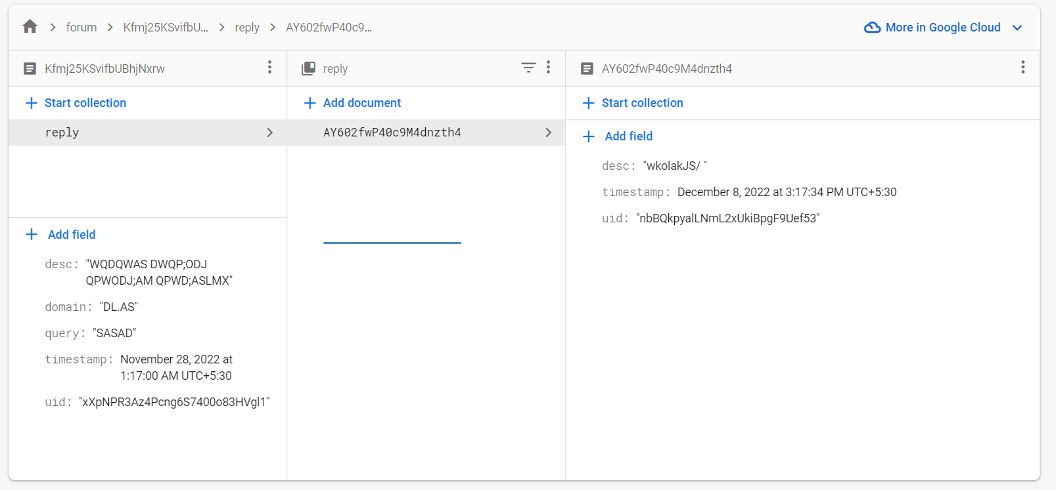

Fig 6.2.5 – Nested collection for forum reply.

The above picture shows the usage of the nested documents in the discussion forums. The reply of each document of forum has a nested document. This nested document has the answer / replies of the users to the posted question.

The fields of the nested document reply are:

1. Description

2. Timestamp

3. uid of the person who answered the question

**6.2.6 Nested collection of Collab Requests:**

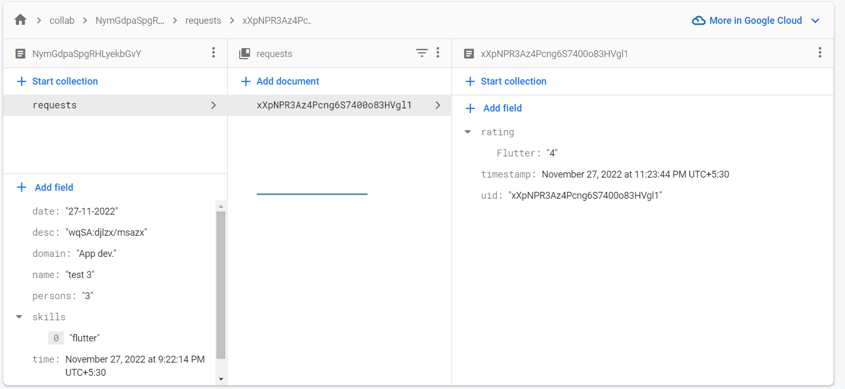

Fig 6.2.6 – Nested collection for collab requests

The above picture shows the usage of the nested documents in the collaborations. The requests of each document of collaborations has a nested document. This nested document has the details of the users who interested to the collab.

The fields of the nested document requests are:

1. Rating to required skills

2. Timestamp

3. uid of the person who interested to collab

**CHAPTER 7**

**CONCLUSION AND FURTHER SCOPE**

**7.1 CONCLUSION**

In this project, we have created a web application where students from VNR VJIRET can form teams and find collaborators for their projects/hackathons. The website also allows users to post any technical/non-technical queries on the forum page where other students can respond. The user also has a dashboard where he/she can accept/reject collab requests from various collaborators. By completing this project we have created a space in the VNR VJIET college where students can collaborate among themselves and also allow cross-domain projects.

**7.2 FUTURE SCOPE**

* Implement text analysis on posts to check the sentiment of the post and automatically delete negative posts.
* Allow photos/videos in the application instead of only text.
* Groups/Chat rooms for various topic-wise discussions.
* Anonymous feature.

**CHAPTER 8**

**BIBLIOGRAPHY**

* + 1. [**https://firebase.google.com/docs/auth**](https://firebase.google.com/docs/auth)
    2. [**https://firebase.google.com/docs/auth/web/google-signin**](https://firebase.google.com/docs/auth/web/google-signin)
    3. [**https://firebase.google.com/docs/hosting**](https://firebase.google.com/docs/hosting)
    4. [**https://stackoverflow.com**](https://stackoverflow.com)
    5. [**https://react-bootstrap.github.io**](https://react-bootstrap.github.io)